**IAM MINI-PROJECT**

## Scenario:

Goldman Sachs is a Fin-Tech company.They are very concerned about their employees' identity , because a compromised identity may lead to access to critical information. So they consulted their business partner IBM located in India and decided to use ISIM (IBM Security Identity Manager).Which is an Identity Management System product from IBM.

As Goldman Sachs is a Fin-Tech Multinational organization located in Americas ,Europe, Middle East and Asia Pacific .Consumer & Investment Management,Engineering,Finance,Global Investment Research, Internal Audit ,Risk and Operations are the divisions in which the organization’s team work.

IBM has 4 employees under ISIM . They are Shreyas Iyer,Shikhar Dhawan, Prithvi Shaw and Axar Patel.And According to the details provided by Goldman Sachs ,DIT should be made to

As the IAM ISIM system was setting up ,Users from locations Americas and Asia Pacific were added through ldif file using inetOrgPerson service feed , under Goldman Sachs. Users from the Middle East were added using Comma-Separated Value (CSV) identity feed of ISIM. While users of Europe through DSML identity Feed Services.

Later on,according to demands Goldman Sachs also decided to use SDS web admin tools. So the users were to be added through ldap browser using ldif file.

Employee details are given in the below link: [Employees Of Goldman Sachs](https://docs.google.com/spreadsheets/d/17GT77yxQKqOzp6xmWsM9sYywgRUthu2oq0oNzdzIT74/edit?usp=sharing)

DIT:

1. **ORGANIZATION GOLDMAN SACHS**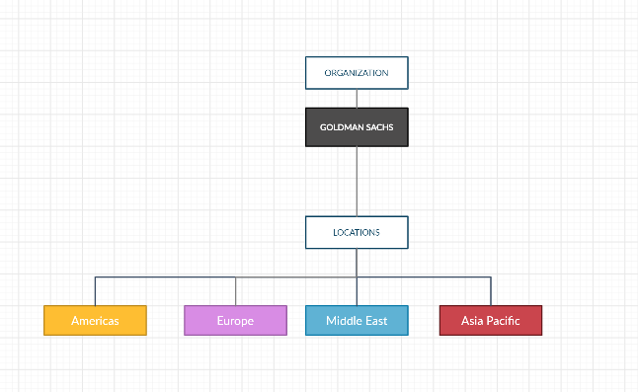
2. **LOCATION AMERICAS**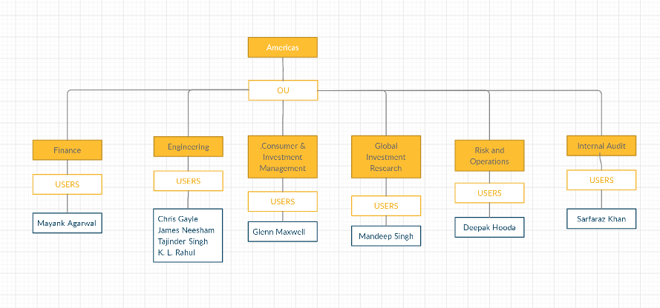
3. **LOCATION EUROPE**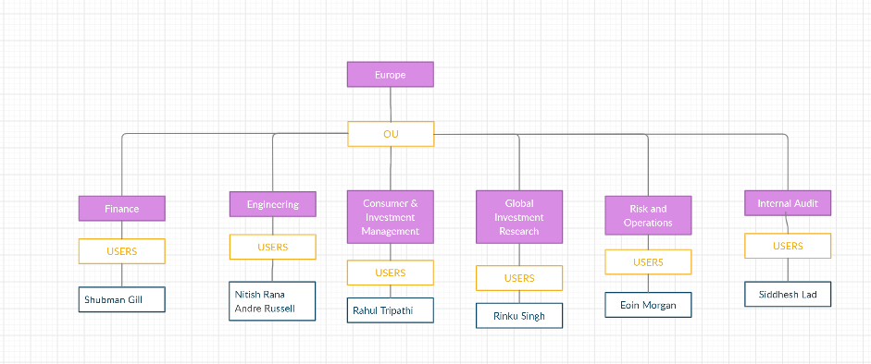

1. **LOCATION MIDDLE EAST**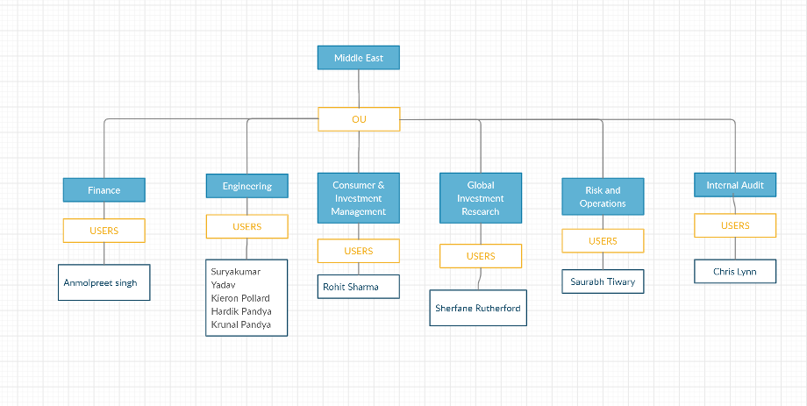
2. **LOCATION ASIA PACIFIC**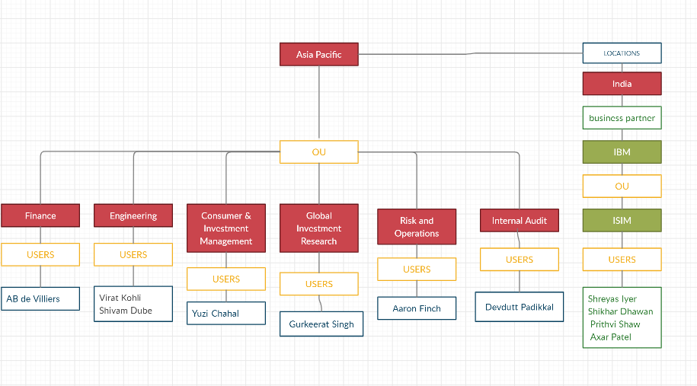

## 

## 

## 

## 

## 

## 

## LDIF FILE:

|  |
| --- |
| dn: o=gs  objectclass: top  objectclass: organization  o: goldman sachs  dn: c=americas,o=gs  objectclass: top  objectclass: country  c: americas  dn: c=europe,o=gs  objectclass: top  objectclass: country  c: europe  dn: c=middle east,o=gs  objectclass: top  objectclass: country  c: middle east  dn: c=asia pacific,o=gs  objectclass: top  objectclass: country  c: asia pacific  dn: c=india,c=asia pacific,o=gs  objectclass: top  objectclass: country  c: india  dn: ou=Finance ,c=americas,o=gs  objectclass: top  objectclass: organizationalUnit  ou: Finance  dn: ou=Engineering ,c=americas,o=gs  objectclass: top  objectclass: organizationalUnit  ou: Engineering  dn: ou=consumer and investment management ,c=americas,o=gs  objectclass: top  objectclass: organizationalUnit  ou: consumer and investment management  dn: ou=global investment research ,c=americas,o=gs  objectclass: top  objectclass: organizationalUnit  ou: global investment research  dn: ou=risk and operations ,c=americas,o=gs  objectclass: top  objectclass: organizationalUnit  ou: risk and operations  dn: ou=internal audit ,c=americas,o=gs  objectclass: top  objectclass: organizationalUnit  ou: internal audit  dn: ou=Finance ,c=europe,o=gs  objectclass: top  objectclass: organizationalUnit  ou: Finance  dn: ou=Engineering ,c=europe,o=gs  objectclass: top  objectclass: organizationalUnit  ou: Engineering  dn: ou=consumer and investment management ,c=europe,o=gs  objectclass: top  objectclass: organizationalUnit  ou: consumer and investment management  dn: ou=global investment research ,c=europe,o=gs  objectclass: top  objectclass: organizationalUnit  ou: global investment research  dn: ou=risk and operations ,c=europe,o=gs  objectclass: top  objectclass: organizationalUnit  ou: risk and operations  dn: ou=internal audit ,c=europe,o=gs  objectclass: top  objectclass: organizationalUnit  ou: internal audit  dn: ou=Finance ,c=middle east,o=gs  objectclass: top  objectclass: organizationalUnit  ou: Finance  dn: ou=Engineering ,c=middle east,o=gs  objectclass: top  objectclass: organizationalUnit  ou: Engineering  dn: ou=consumer and investment management ,c=middle east,o=gs  objectclass: top  objectclass: organizationalUnit  ou: consumer and investment management  dn: ou=global investment research ,c=middle east,o=gs  objectclass: top  objectclass: organizationalUnit  ou: global investment research  dn: ou=risk and operations ,c=middle east,o=gs  objectclass: top  objectclass: organizationalUnit  ou: risk and operations  dn: ou=internal audit ,c=middle east,o=gs  objectclass: top  objectclass: organizationalUnit  ou: internal audit  dn: ou=Finance ,c=asia pacific,o=gs  objectclass: top  objectclass: organizationalUnit  ou: Finance  dn: ou=Engineering ,c=asia pacific,o=gs  objectclass: top  objectclass: organizationalUnit  ou: Engineering  dn: ou=consumer and investment management ,c=asia pacific,o=gs  objectclass: top  objectclass: organizationalUnit  ou: consumer and investment management  dn: ou=global investment research ,c=asia pacific,o=gs  objectclass: top  objectclass: organizationalUnit  ou: global investment research  dn: ou=risk and operations ,c=asia pacific,o=gs  objectclass: top  objectclass: organizationalUnit  ou: risk and operations  dn: ou=internal audit ,c=asia pacific,o=gs  objectclass: top  objectclass: organizationalUnit  ou: internal audit  dn: ou=ibm ,c=india,c=asia pacific,o=gs  objectclass: top  objectclass: organizationalUnit  ou: ibm  dn: ou=isim,ou=ibm ,c=india,c=asia pacific,o=gs  objectclass: top  objectclass: organizationalUnit  ou: isim  dn: uid=magarwal,ou=Finance ,c=americas,o=gs  objectclass: top  objectclass: inetorgperson  objectclass: organizationalPerson  objectclass: person  sn: Agarwal  cn: Mayank Agarwal  uid: magarwal  dn: uid=cgayle,ou=Engineering ,c=americas,o=gs  objectclass: top  objectclass: inetorgperson  objectclass: organizationalPerson  objectclass: person  sn: Gayle  cn: Chris Gayle  uid: cgayle  dn: uid=jneesham,ou=Engineering ,c=americas,o=gs  objectclass: top  objectclass: inetorgperson  objectclass: organizationalPerson  objectclass: person  sn: Neesham  cn: James Neesham  uid: jneesham  dn: uid=tsingh,ou=Engineering ,c=americas,o=gs  objectclass: top  objectclass: inetorgperson  objectclass: organizationalPerson  objectclass: person  sn: Singh  cn: Tajinder Singh  uid: tsingh  dn: uid=klrahul,ou=Engineering ,c=americas,o=gs  objectclass: top  objectclass: inetorgperson  objectclass: organizationalPerson  objectclass: person  sn: Rahul  cn: KL Rahul  uid: klrahul  dn: uid=gmaxwell,ou=consumer and investment management ,c=americas,o=gs  objectclass: top  objectclass: inetorgperson  objectclass: organizationalPerson  objectclass: person  sn: Maxwell  cn: Glenn Maxwell  uid: gmaxwell  dn: uid=msingh,ou=global investment research ,c=americas,o=gs  objectclass: inetorgperson  objectclass: organizationalPerson  objectclass: person  sn: Singh  cn: Mandeep Singh  uid: msingh  dn: uid=dhooda,ou=risk and operations ,c=americas,o=gs  objectclass: top  objectclass: inetorgperson  objectclass: organizationalPerson  objectclass: person  sn: Hooda  cn: Deepak Hooda  uid: dhooda  dn: uid=skhan,ou=internal audit,c=americas,o=gs  objectclass: top  objectclass: inetorgperson  objectclass: organizationalPerson  objectclass: person  sn: Khan  cn: Sarfaraz Khan  uid: skhan  dn: uid=sgill,ou=Finance ,c=europe,o=gs  objectclass: top  objectclass: inetorgperson  objectclass: organizationalPerson  objectclass: person  sn: Gill  cn: Shubman Gill  uid: sgill  dn: uid=nrana,ou=Engineering ,c=europe,o=gs  objectclass: top  objectclass: inetorgperson  objectclass: organizationalPerson  objectclass: person  sn: Rana  cn: Nitish Rana  uid: nrana  dn: uid=arussell,ou=Engineering ,c=europe,o=gs  objectclass: top  objectclass: inetorgperson  objectclass: organizationalPerson  objectclass: person  sn: Russell  cn: Andre Russell  uid: arussell  dn: uid=rtripathi,ou=consumer and investment management ,c=europe,o=gs  objectclass: top  objectclass: inetorgperson  objectclass: organizationalPerson  objectclass: person  sn: Tripathi  cn: Rahul Tripathi  uid: rtripathi  dn: uid=rsingh,ou=global investment research ,c=europe,o=gs  objectclass: inetorgperson  objectclass: organizationalPerson  objectclass: person  sn: Singh  cn: Rinku Singh  uid: rsingh  dn: uid=emorgan,ou=risk and operations ,c=europe,o=gs  objectclass: top  objectclass: inetorgperson  objectclass: organizationalPerson  objectclass: person  sn: Morgan  cn: Eoin Morgan  uid: emorgan  dn: uid=slad,ou=internal audit,c=europe,o=gs  objectclass: top  objectclass: inetorgperson  objectclass: organizationalPerson  objectclass: person  sn: Lad  cn: Siddhesh Lad  uid: slad  dn: uid=asingh,ou=Finance ,c=middle east,o=gs  objectclass: top  objectclass: inetorgperson  objectclass: organizationalPerson  objectclass: person  sn: Singh  cn: Anmolpreet Singh  uid: ansingh  dn: uid=syadav,ou=Engineering ,c=middle east,o=gs  objectclass: top  objectclass: inetorgperson  objectclass: organizationalPerson  objectclass: person  sn: Yadav  cn: Suryakumar Yadav  uid: syadav  dn: uid=kpollard,ou=Engineering ,c=middle east,o=gs  objectclass: top  objectclass: inetorgperson  objectclass: organizationalPerson  objectclass: person  sn: Pollard  cn: Kieron Pollard  uid: kpollard  dn: uid=hpandya,ou=Engineering ,c=middle east,o=gs  objectclass: top  objectclass: inetorgperson  objectclass: organizationalPerson  objectclass: person  sn: Pandya  cn: Hardik Pandya  uid: hpandya  dn: uid=kpandya,ou=Engineering ,c=middle east,o=gs  objectclass: top  objectclass: inetorgperson  objectclass: organizationalPerson  objectclass: person  sn: Pandya  cn: Krunal Pandya  uid: kpandya  dn: uid=rsharma,ou=consumer and investment management ,c=middle east,o=gs  objectclass: top  objectclass: inetorgperson  objectclass: organizationalPerson  objectclass: person  sn: Sharma  cn: Rohit Sharma  uid: rsharma  dn: uid=srutherford,ou=global investment research ,c=middle east,o=gs  objectclass: inetorgperson  objectclass: organizationalPerson  objectclass: person  sn: Rutherford  cn: Sherfane Rutherford  uid: srutherford  dn: uid=stiwary,ou=risk and operations ,c=middle east,o=gs  objectclass: top  objectclass: inetorgperson  objectclass: organizationalPerson  objectclass: person  sn: Tiwary  cn: Saurabh Tiwary  uid: stiwary  dn: uid=slynn,ou=internal audit,c=middle east,o=gs  objectclass: top  objectclass: inetorgperson  objectclass: organizationalPerson  objectclass: person  sn: Lynn  cn: Chris Lynn  uid: clynn  dn: uid=vkohli,ou=Engineering ,c=asia pacific,o=gs  objectclass: top  objectclass: inetorgperson  objectclass: organizationalPerson  objectclass: person  sn: kohli  cn: Virat Kohli  uid: vkohli  dn: uid=sdube,ou=Engineering ,c=asia pacific,o=gs  objectclass: top  objectclass: inetorgperson  objectclass: organizationalPerson  objectclass: person  sn: Dube  cn: Shivam Dube  uid: sdube  dn: uid=abdvilliers,ou=Finance ,c=asia pacific,o=gs  objectclass: top  objectclass: inetorgperson  objectclass: organizationalPerson  objectclass: person  sn: Villiers  cn: AB de Villiers  uid: abdvilliers  dn: uid=ychahal,ou=consumer and investment management ,c=asia pacific,o=gs  objectclass: top  objectclass: inetorgperson  objectclass: organizationalPerson  objectclass: person  sn: chahal  cn: Yuzi Chahal  uid: ychahal  dn: uid=singh,ou=global investment research ,c=asia pacific,o=gs  objectclass: inetorgperson  objectclass: organizationalPerson  objectclass: person  sn: Singh  cn: Gurkeerat Singh  uid: gsingh  dn: uid=afinch,ou=risk and operations ,c=asia pacific,o=gs  objectclass: top  objectclass: inetorgperson  objectclass: organizationalPerson  objectclass: person  sn: finch  cn: Aaron Finch  uid: afinch  dn: uid=dpadikkal,ou=internal audit,c=asia pacific,o=gs  objectclass: top  objectclass: inetorgperson  objectclass: organizationalPerson  objectclass: person  sn: padikkal  cn: Devdutt Padikkal  uid: dpadikkal  dn: uid=siyer,ou=isim ,ou=ibm ,c=india,c=asia pacific,o=gs  objectclass: top  objectclass: inetorgperson  objectclass: organizationalPerson  objectclass: person  sn: iyer  cn: Shreyas Iyer  uid: siyer  dn: uid=pshaw,ou=isim ,ou=ibm ,c=india,c=asia pacific,o=gs  objectclass: top  objectclass: inetorgperson  objectclass: organizationalPerson  objectclass: person  sn: shaw  cn: Prithvi Shaw  uid: pshaw  dn: uid=sdhawan,ou=isim ,ou=ibm ,c=india,c=asia pacific,o=gs  objectclass: top  objectclass: inetorgperson  objectclass: organizationalPerson  objectclass: person  sn: Dhawan  cn: Shikhar Dhawan  uid: sdhawan  dn: uid=apatel,ou=isim ,ou=ibm ,c=india,c=asia pacific,o=gs  objectclass: top  objectclass: inetorgperson  objectclass: organizationalPerson  objectclass: person  sn: Patel  cn: Axar Patel  uid: apatel |

## 

## 

## 

## 

## 

## 

## 

## DSML FILES:(Location = Europe)

1. For ou= Finance

|  |
| --- |
| <dsml><directory-entries>  <entry dn="uid=sgill">  <objectclass><oc-value>inetOrgPerson</oc-value></objectclass>  <attr name="givenname"><value>Shubman</value></attr>  <attr name="sn"><value>Gill</value></attr>  <attr name="cn"><value>Shubman Gill</value></attr>  <attr name="telephonenumber"><value>800-555-4002</value></attr>  <attr name="departmentnumber"><value>Finance</value></attr>  <attr name="title"><value>Finance at GS</value></attr>  <attr name="manager"><value>Shreyas Iyer</value></attr>  <attr name="employeenumber"><value>123442</value></attr>  <attr name="mail"><value>sgill@gs.com</value></attr>  </entry>  </directory-entries></dsml> |

1. For ou= Engineering

|  |
| --- |
| <dsml><directory-entries>  <entry dn="uid=nrana">  <objectclass><oc-value>inetOrgPerson</oc-value></objectclass>  <attr name="givenname"><value>Nitish</value></attr>  <attr name="sn"><value>Rana</value></attr>  <attr name="cn"><value>Nitish Rana</value></attr>  <attr name="telephonenumber"><value>800-555-4001</value></attr>  <attr name="departmentnumber"><value>Engineering</value></attr>  <attr name="title"><value>Engineering at GS</value></attr>  <attr name="manager"><value>Shreyas Iyer</value></attr>  <attr name="employeenumber"><value>123441</value></attr>  <attr name="mail"><value>nrana@gs.com</value></attr>  </entry>  <entry dn="uid=arussell">  <objectclass><oc-value>inetOrgPerson</oc-value></objectclass>  <attr name="givenname"><value>Andre</value></attr>  <attr name="sn"><value>Russell</value></attr>  <attr name="cn"><value>Andre Russell</value></attr>  <attr name="telephonenumber"><value>800-555-4007</value></attr>  <attr name="departmentnumber"><value>Engineering</value></attr>  <attr name="title"><value>Engineering at GS</value></attr>  <attr name="manager"><value>Shreyas Iyer</value></attr>  <attr name="employeenumber"><value>123447</value></attr>  <attr name="mail"><value>arussell@gs.com</value></attr>  </entry>  </directory-entries></dsml> |

1. For ou= CIM

|  |
| --- |
| <dsml><directory-entries>  <entry dn="uid=rtripathi">  <objectclass><oc-value>inetOrgPerson</oc-value></objectclass>  <attr name="givenname"><value>Rahul</value></attr>  <attr name="sn"><value>Tripathi</value></attr>  <attr name="cn"><value>Rahul Tripathi</value></attr>  <attr name="telephonenumber"><value>800-555-4006</value></attr>  <attr name="departmentnumber"><value>CIM</value></attr>  <attr name="title"><value>CIM at GS</value></attr>  <attr name="manager"><value>Shreyas Iyer</value></attr>  <attr name="employeenumber"><value>123446</value></attr>  <attr name="mail"><value>rtripathi@gs.com</value></attr>  </entry>  </directory-entries></dsml> |

1. For ou= Risk and Operation

|  |
| --- |
| <dsml><directory-entries>  <entry dn="uid=emorgan">  <objectclass><oc-value>inetOrgPerson</oc-value></objectclass>  <attr name="givenname"><value>Eoin</value></attr>  <attr name="sn"><value>Morgan</value></attr>  <attr name="cn"><value>Eoin Morgan</value></attr>  <attr name="telephonenumber"><value>800-555-4005</value></attr>  <attr name="departmentnumber"><value>Risk and Operations</value></attr>  <attr name="title"><value>Risk and Operations at GS</value></attr>  <attr name="manager"><value>Shreyas Iyer</value></attr>  <attr name="employeenumber"><value>123445</value></attr>  <attr name="mail"><value>emorgan@gs.com</value></attr>  </entry>  </directory-entries></dsml> |

1. For ou= GIR

|  |
| --- |
| <dsml><directory-entries>  <entry dn="uid=rsingh">  <objectclass><oc-value>inetOrgPerson</oc-value></objectclass>  <attr name="givenname"><value>Rinku</value></attr>  <attr name="sn"><value>Singh</value></attr>  <attr name="cn"><value>Rinku Singh</value></attr>  <attr name="telephonenumber"><value>800-555-4003</value></attr>  <attr name="departmentnumber"><value>GIR</value></attr>  <attr name="title"><value>GIR at GS</value></attr>  <attr name="manager"><value>Shreyas Iyer</value></attr>  <attr name="employeenumber"><value>123443</value></attr>  <attr name="mail"><value>rsingh@gs.com</value></attr>  </entry>  </directory-entries></dsml> |

1. For ou= Internal Audit

|  |
| --- |
| <dsml><directory-entries>  <entry dn="uid=slad">  <objectclass><oc-value>inetOrgPerson</oc-value></objectclass>  <attr name="givenname"><value>Siddhesh</value></attr>  <attr name="sn"><value>Lad</value></attr>  <attr name="cn"><value>Siddhesh Lad</value></attr>  <attr name="telephonenumber"><value>800-555-4004</value></attr>  <attr name="departmentnumber"><value>Internal Audit</value></attr>  <attr name="title"><value>Internal Audit at GS</value></attr>  <attr name="manager"><value>Shreyas Iyer</value></attr>  <attr name="employeenumber"><value>123444</value></attr>  <attr name="mail"><value>slad@gs.com</value></attr>  </entry>  </directory-entries></dsml> |

## CSV FILES:(Location = Middle East)

## [CSV FILES FOR MIDDLE EAST](https://drive.google.com/drive/folders/1TbBN4Ry-uetPed0CKUXyA_eIWvEXzMoq?usp=sharing)

## 

## 

## 

## 

## 

## 

## Implementation:

## Implementation in ISIM CONSOLE:

Tasks :

1. Create an organization tree .
2. Create a new role(GS-MANAGER) .
3. Create a new user(GS-ADMIN) to manage the users.
4. Make organization structure.
5. Add Services to add users.
6. Add Users according to the services.

Implementation:

1. Creating the organization(Goldman Sachs)
   1. Login to isim console.
   2. In Manage Organization Structure Create Organization.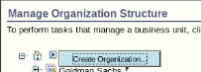
   3. Add Organization details and click OK.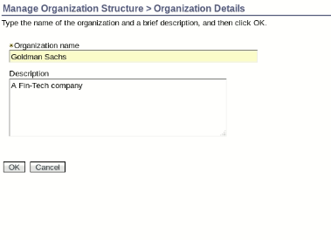
2. Create a new role(GS-MANAGER).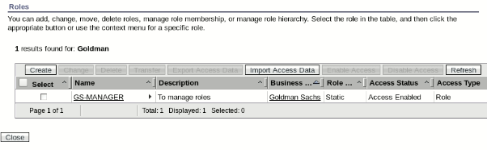
3. Create a new user(GS Admin) to manage the users using the GS-MANAGER role.
4. Now, making the organization structure by adding locations , organizational units and business partners .
   1. Adding the locations Americas,Europe,Middle east and Asia pacific.
      1. Adding Location Americas.
         1. Select Create Location in Goldman Sachs. 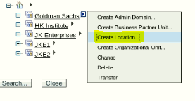
         2. Adding Location Details and clicking on OK.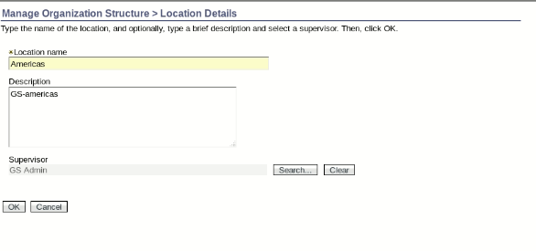
      2. Adding Locations middle east ,asia pacific and europe similarly.

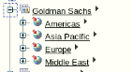

* 1. Adding organizational units
     1. In the Americas ,
        1. Click on the triangle and select create organizational unit . 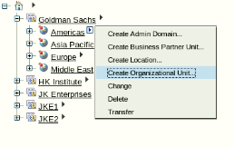
        2. Enter the details and click on OK.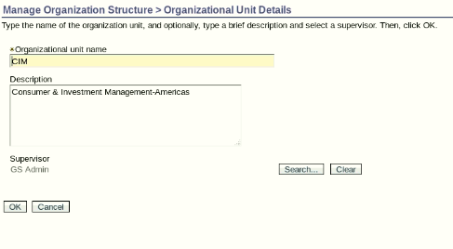
        3. Similarly add other organizational units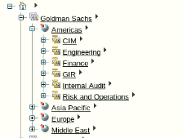
     2. Now similarly adding organizational units under the remaining location accordingly.
  2. Adding Business partner in India ,under asia pacific region
     1. Add location India
     2. Create a business partner IBM in India.
        1. Click on create business partner and add details.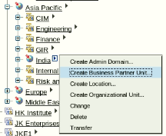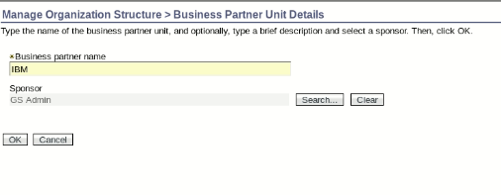
        2. Under IBM ,create an organizational unit ISIM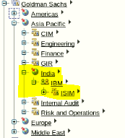

Organization Structure: 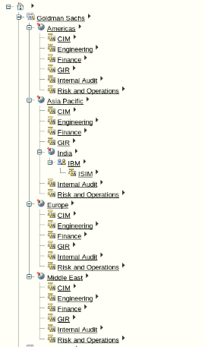

1. Adding Services to add users in their business unit respectively.
   1. For Location Middle East,Create a Comma-Separated Value (CSV) identity feed services for all the organizational units
      1. Creating CSV-ENG-ME-GS for organizational unit engineering
         1. In Manage Services ,click on create to create a new service. 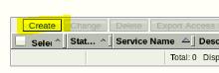
         2. Selecting the organizational unit engineering and Comma-Separated Value (CSV) identity feed service.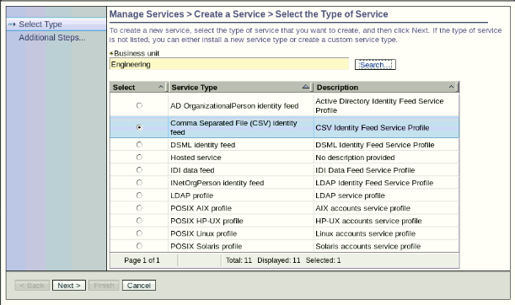
         3. Enter the details and test the connection,after successful compilation click OK.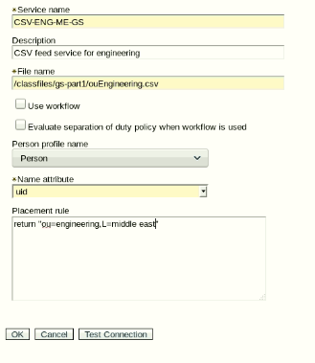
         4. Check the newly created service in manage services after refreshing and then click the triangle on the newly created service to Reconcile now.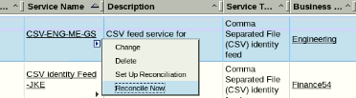
         5. After Reconciliation Check the Result .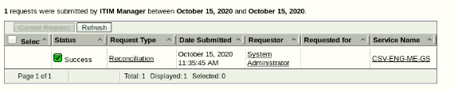
      2. Similarly Add all other services for the Middle East and reconcile them .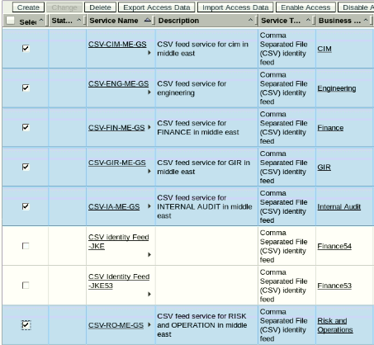
   2. For Location Europe,Create a DSML identity Feed Services for all the organizational units under Europe.
      1. Creating DSML-ENG-EU-GS for organizational unit engineering
         1. In Manage Services ,click on create to create a new service. 
         2. Selecting Business unit Engineering and service type DSML identity feed Click next. 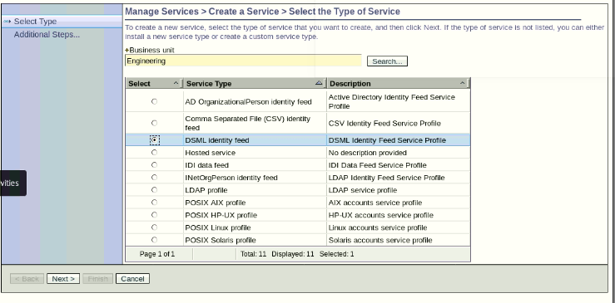
         3. Filling up the details and then testing the connection after the successful compilation click OK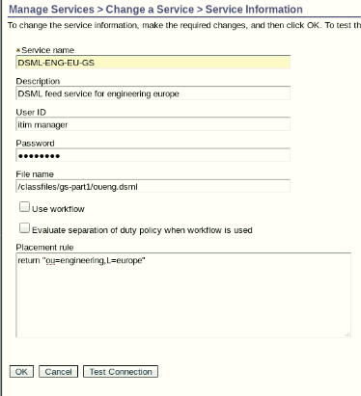
         4. Check the newly created service in manage services after refreshing and then click the triangle on the newly created service to Reconcile now.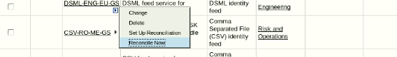
         5. After Reconciliation Check the Result 
      2. Similarly Add all other services for the Middle East and reconcile them 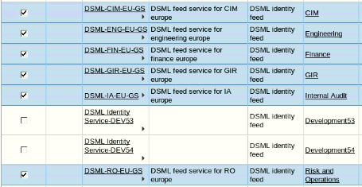
   3. Creating LDAP InetOrgPerson identity feed
      1. Preparing for the load
         1. Open the LDAP Browser from Desktop and create .
            1. Enter Name netgs.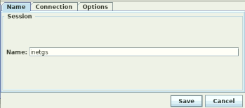
            2. Enter the details and fetch DNs o=gs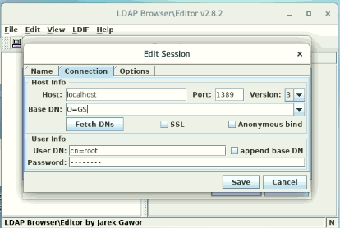
      2. Creating and testing the identity feed.
         1. In Manage Services ,click on create to create a new service. 
         2. Selecting Business unit Engineering and service type LDAP InetOrgPerson identity feed.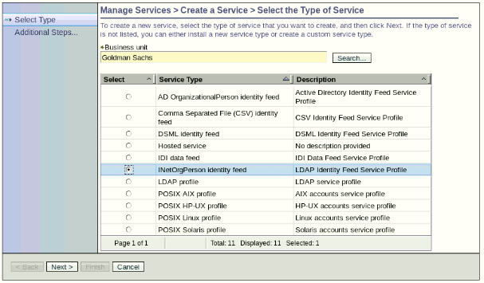
         3. Filling up the details and then testing the connection after the successful compilation click OK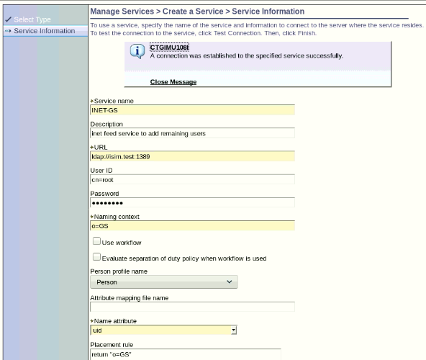
         4. Check the newly created service in manage services after refreshing and then click the triangle on the newly created service to Reconcile now.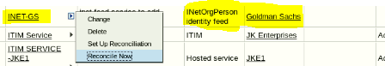
         5. After Reconciliation Check the Result
2. Checking the Users after reconciliation.
   1. Users of the Middle East.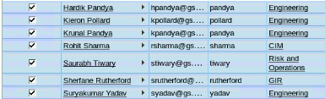
   2. Users of Europe.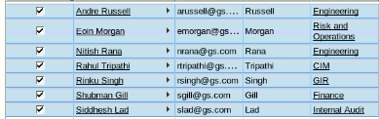
   3. Users of Asia Pacific and Americas under organization.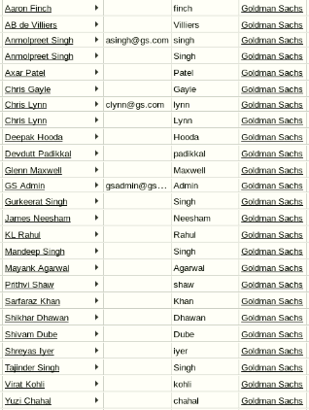

## Implementation in SDS WEB ADMIN using LDAP Browser:

Tasks :

1. Stop the Server instance to add Suffix
2. Add the Suffix
3. Start Server Instance
4. Add organization information
5. Import Ldif file using ldap browser

Implementation :

1. Listing server instances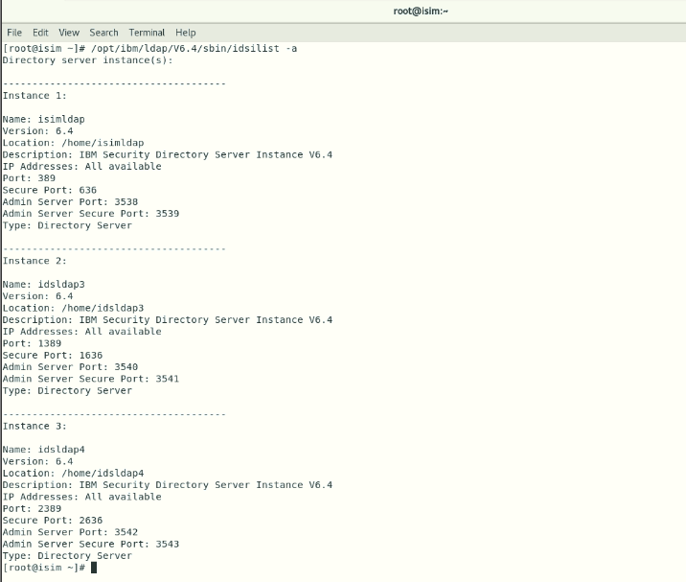
2. Stop the Server instance
3. Adding the Suffix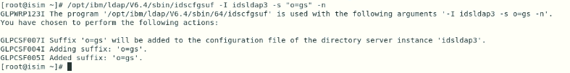
4. Start Server Instance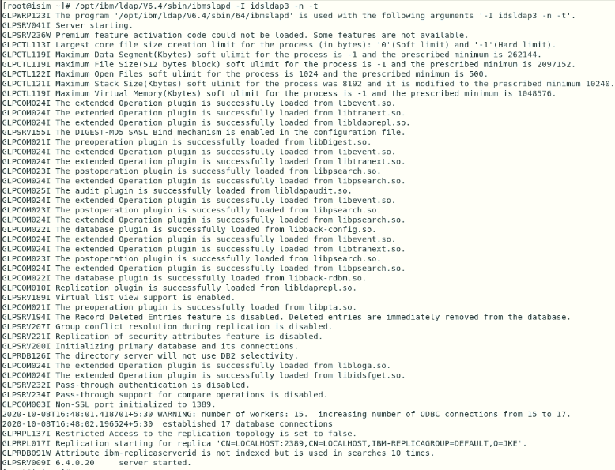
5. Add gs organization information to the directory tree: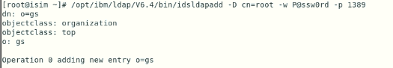Check organization in SDS Web Admin Tool.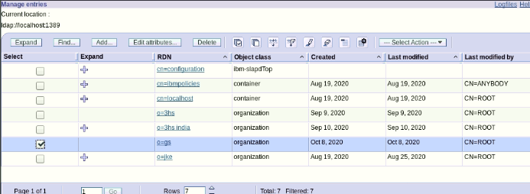
6. Import Ldif file using ldap browser
   1. Open Ldap browser
   2. Create new session(name:GS)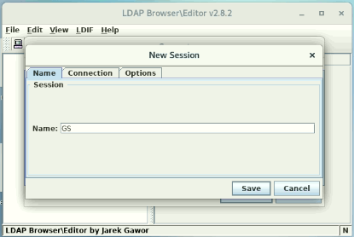
   3. Add the connection details and then save the session.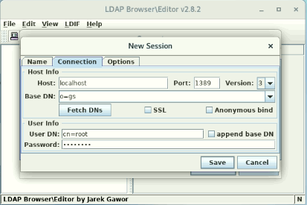
   4. Now connect to the newly created session(GS)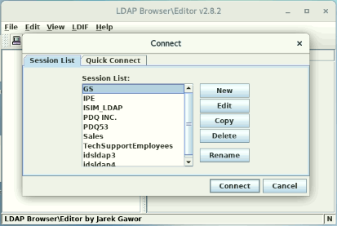
   5. In Ldif click on import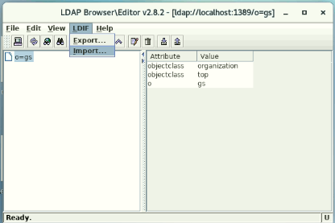
   6. Choose the ldif file to import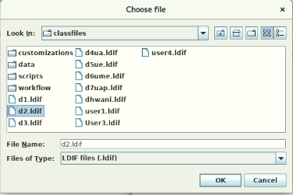
   7. After selecting the ldif file, click on OK to update.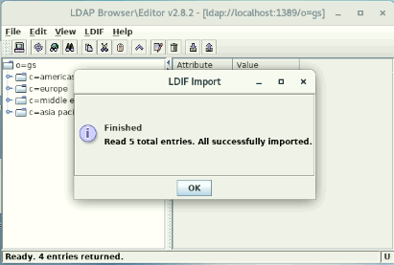
   8. Similarly import All the Other ldif files
   9. Check the DIT
      1. Expanding for location Americas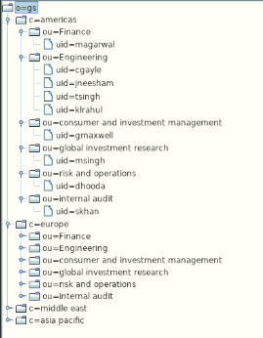
      2. Expanding for location Europe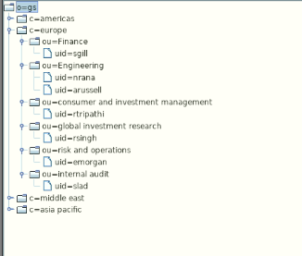
      3. Expanding for location Middle East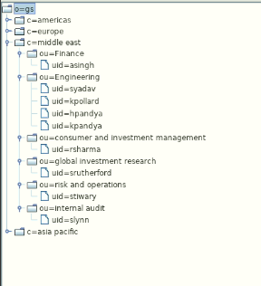
      4. Expanding for location Asia Pacific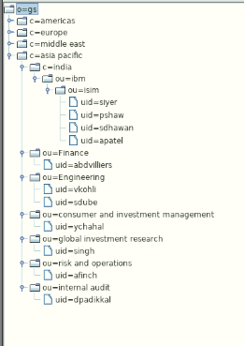
7. Verify details in SDS Web Admin Tool .

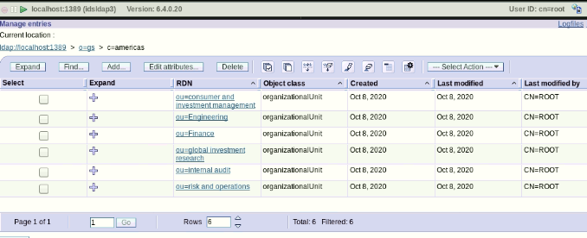

## 

## Conclusion:

*By implementing a reliable IAM program, a company can strike a balance between security, risk reduction, training its staff (including customers and employees) to use the services they need, whenever they need them, without taking too many digital risks. In the light of advantages and failure prevention that an access management system can provide to applications, it is highly recommended that it receives due attention. Doing so can prevent data breaches; financial and reputational damage to your company.*